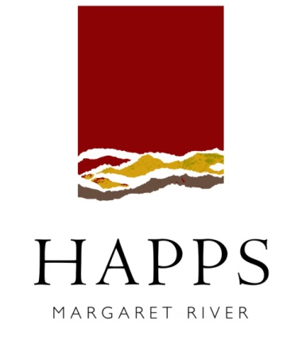

Rotary Club of Freshwater Bay
Fundraiser 2018

WINE ORDER FORM
Minimum order of 12 bottles and multiples thereof: mixed or straight dozens
Fundraiser Wines – Happs Estate | Normal price per bottle | Fundraiser price per bottle | Qty (bottles) | Sub total  $
Happs 2016 Sauv Blanc Semillon | $24.00 | $15.00
Happs 2016 White Fuchsia (sweet white) | $20.00 | $15.00
Happs 2016 Dry Rosé | $22.00 | $12.50
Happs 2015 Cabernet Merlot | $30.00 | $18.00
iSeries 2012 & 2014 Semillon | $17.00 | $10.00
iSeries 2014 Pinot Noir | $17.00 | $10.00
iSeries 2011 East of Alice Red | $17.00 | $10.00
Totals |  |  | # | $

Please send your wine order form to Sec. Di Collins E: collinsd@bigpond.net.au by 28th February, 2018.
Order payments will be processed by Happs Wines who will deliver directly to the Rotary Club.
An email will be sent out to advise when your wine is ready to be collected from the club.

Thank you for your support!

Please mark with a cross if you DO NOT wish to receive the Happs Wines newsletter

First Name _____________________________ |  |  |  |  |  |  |  | Surname:
Address:
Suburb/Town: |  |  |  |  |  |  |  |  | State
Postcode: |  |  |  |  | E-mail:
Phone
Please debit my: | Bcard |  |  | Mcard |  |  | Visa |  |  | Expiry date |  | /

CCV____ Card #

Please print contact phone number and credit card details very clearly

